Усилители
DSD800/ 1800 /3200 /4000
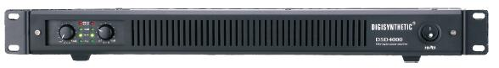
Applies the classical PWM circuit design and new technology protection circuit.
●Applies excellent power-supply design, reliable circuit, high efficiency and lowdistortion.
●New modulation mode helps to taking sample of extremely small signal, to improve and perfect the method of sampling.
●High switchmode frequency, precise controlling of dead-time, makes the distortion of the amplifier muchlower, the sound quality reaches and even passes thetraditional transformeramplifier.
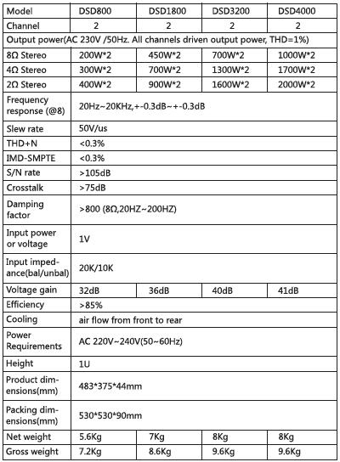

DH 500/700/900/1200/1400/1800
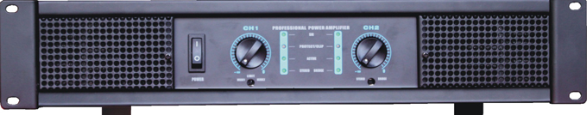
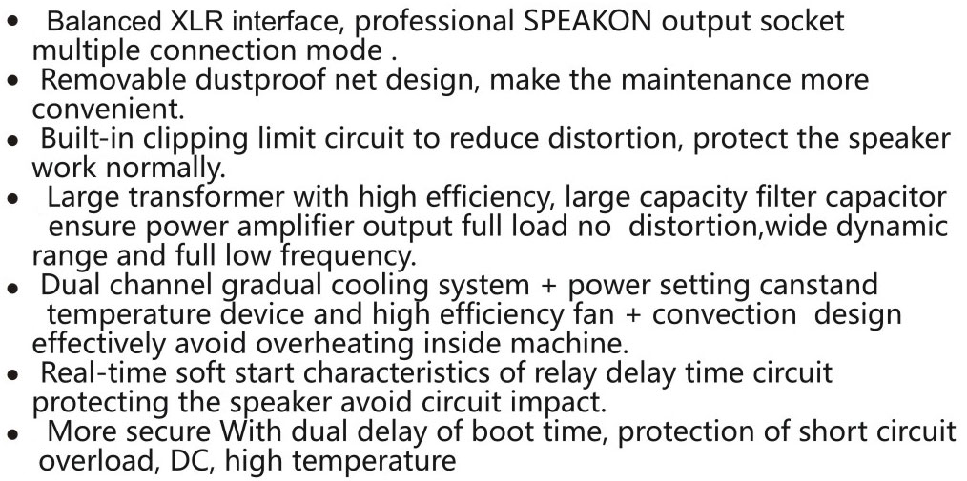
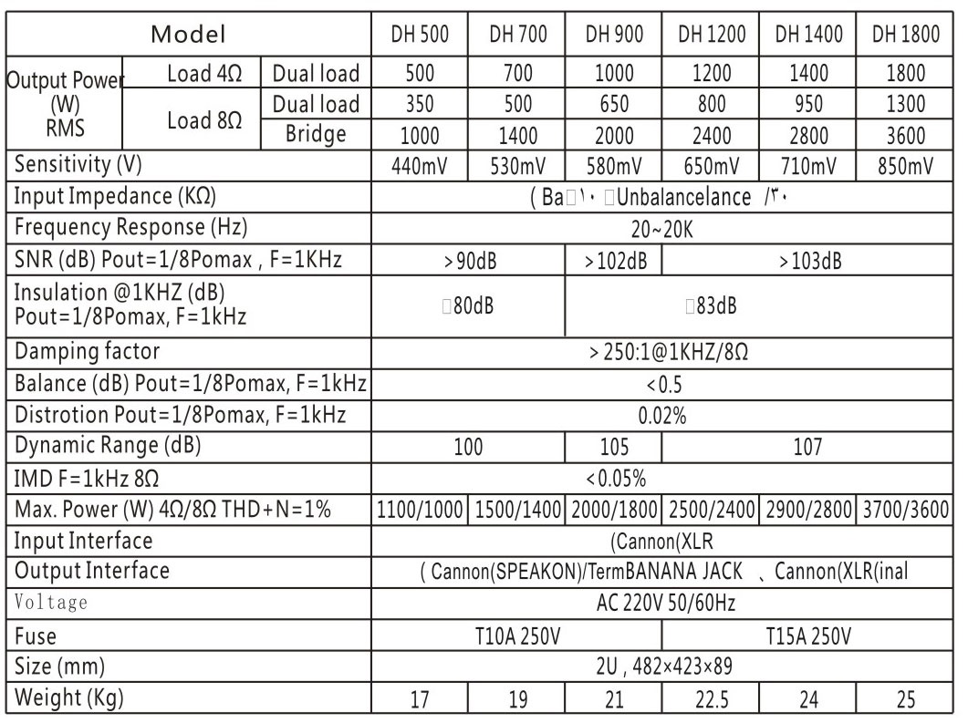

DSI6400/DSI5600/DSI4000/DSI3600/DSI2400
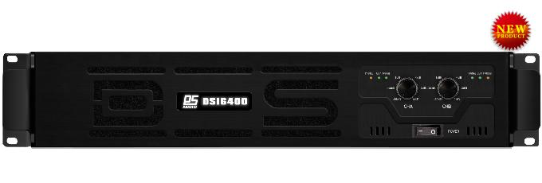
• Switch power supply and class Damplifier,
• reliable and stable design overcomes the shortcoming of class D amplifier
• and features high efficiency at the same time.
• Perfect protection and efficient heat removal system makes the performance more stable.
• Bass is broad and pliancy, mediant is plump and bright, treble level is rich.
• State-of-the-art craft, high quality standard of the components

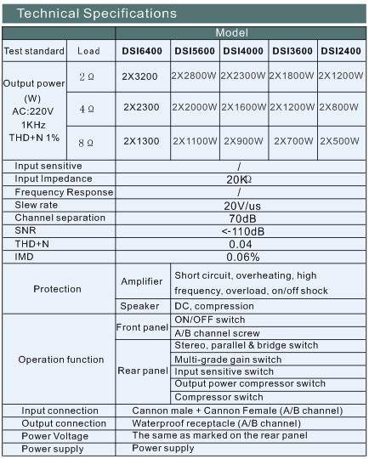

DP4800/3200/2240/1800/1400
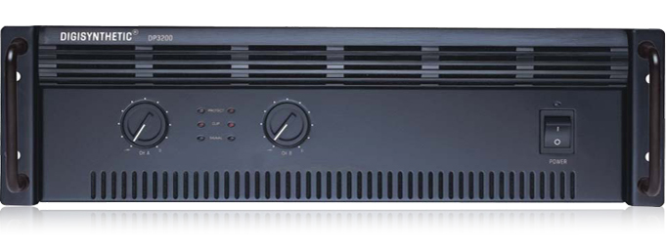
● Stable and reliable design, powered by traditional round transformer
● Bass is broad and pliancy, mediant is plump and bright, treble level is rich
● Perfect protection: turn on/off impact protection, thermal protection, electronic soft protection, short circuit and DC protection.
● Have higher cooling efficiency and reliability after adopt double heat sink and double variable-speed fans .
Model No. |  |  | DP4800 |  | DP3200 |  | DP2240 |  | DP1800 |  | DP1400
RMS | 8Ω |  | 4×450W |  | 2×1100W |  | 2×900W |  | 2×700W |  | 2×450W
 | 4Ω |  | 4×700W |  | 2×1700W |  | 2×1300W |  | 2×1000W |  | 2×700W
 | Bridge |  | 1300W(8Ω)(only DSP4800 & DSP1400)
Electrical specifications
Input | Sensitivity | 0dB (0.775Vrms)
 | Impedance | 30KΩ (balance)
Frequency response |  | 20-20000Hz(±0.5dB)
Slew rate |  | ≥20 V/us
Damping factor |  | >250:1(@1Khz / 8Ω)
SNR |  | >95dB
THD + N |  | 0.08% @1KHz
IMD |  | 0.1% 8Ω, 1KHz@1W
Parameters of the machine
Protection | Power amplifier | Turn on/off impact, thermal, electronic software, short circuit.
 | Speaker | Compression & DC protection
Operation function | Front panel | Power on/off
 |  | Volume knob for A/B channel.
 | ear panel | GND switch
Input/Output connection port | Input | Cannon M + Cannon F ( A/B channel )
 | Output | Waterproof socket ( A/B channel )
Rack |  | 3U
Weight |  | 39kg |  | 40kg |  | 37kg |  | 34kg |  | 30kg
Size |  | 483mm×487mm×130mm

DSP4800/3200/2240/1800/1400
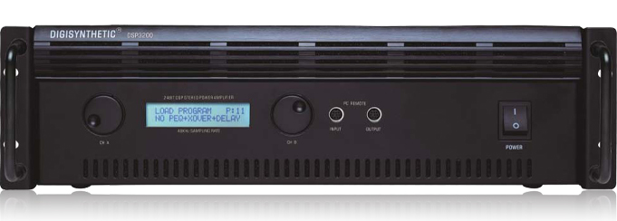
● System integration design
● Perfect protection: short circuit/overload, thermal, DC offset, Network control
● Suitable for different request of power allocation
● Uilt-in 24-bit DSP, dynamic range 116dB, high performance AD/DA, 48KHz sampling rate. Low noise and distortion
● Special design digital signal generator(sine wave and white noise ).
● 10 user memories, data stored with 20years valid period
● Digital audio(S/P DIF) input/output selectable Max. 255 units can be controlled via select address code. PC control via RS485 port. PC interface with 2 languages(Chinese/English ), very convenient to recall/store all parameters.
● 5 bands PEQ, Limit (threshold, attack time and release time adjustable ), delay (max. 7ms), phase reversal, input gain adjustable. 2-crossover between 20Hz ~ 20KHz. Crossover point adjustable, crossover slope and type: -6dB,-12dB, -18dB, -24dB, Butterworth, Linkwitz-Riley or Bessel
 |  | DSP4800 | DSP3200 | DSP2240 | DSP1800 | DSP1400
RMS | 8Ω | 4×450W | 2×1100W | 2×900W | 2×700W | 2×450W
 | 4Ω | 4×750W | 2×1700W | 2×1300W | 2×1000W | 2×700W
 | Bridge | 1300W(8Ω)(only DSP4800 & DSP1400)
SNR |  | >90dB
THD + N |  | 0.08% @1KHz
IMD |  | 0.1% 8Ω, 1KHz@1W
Frequency response |  | 20Hz-20kHz(+0, -0.5dB)
Input sensitivity/impedance |  | 0dB(0.775Vrms)/30KΩ
Crosstalk |  | >50dB
Channel separation |  | >500:1 @1KHz/8Ω
Phase response |  | -18°@20KHz +25°@20KHz
Voltage gain |  | 40dB@1KHz/8Ω
Protection |  | DC, short circuit, overload
Voltage |  | AC220V±10% 50-60Hz
Rack |  | 3U
Weight |  | 40kg | 43kg | 39kg | 35kg | 29kg
Size |  | 482mm×377mm×130mm

DSP2.1S
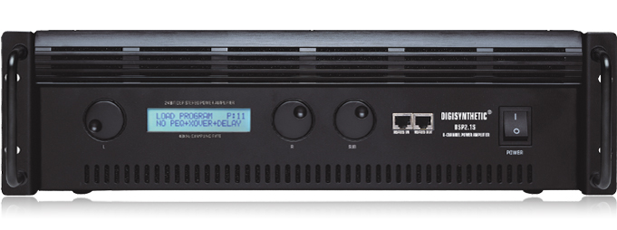
● System integration design
● Perfect protection: short circuit/overload, thermal, DC offset, Network control
● 2 inputs /3 outputs, subwoofer output from 2 inputs
● Suitable for different request of power allocation
● Uilt-in 24-bit DSP, dynamic range 116dB, high performance AD/DA, 48KHz sampling rate. Low noise and distortion
● Special design digital signal generator (sine wave and white noise)
● 10 user memories, data stored with 20years valid period
● Digital audio(S/P DIF) input/output, top quality signal divider (option), matrix routing control function, Max. 255 units can be controlled via select address code. PC control via RS485 port.
PC interface with 2 languages(Chinese/English), very convenient to recall/store all parameters
● 5 bands PEQ, Limit (threshold, attack time and release time adjustable), delay (max. 7ms), phase reversal, input gain adjustable. 2-crossover between 20Hz ~ 20KHz. Crossover point adjustable, crossover slope and type: -6dB,-12dB, -18dB, -24dB, Butterworth, Linkwitz-Riley or Bessel Variable Q’value filter
RMS
Left & right channel | 8Ω | 300W
 | 4Ω | 500W
 | 2Ω | 700 W
Woofer channe | 8Ω | 400 W
 | 4Ω | 650 W
 | 2Ω | 850 W
SNR |  | >90dB
THD + N |  | 0.1% @1KHz
IMD |  | 0.1% 8Ω, 1KHz@1W
Frequency response |  | 20Hz-20KHz(+0, -0.5dB)
Input sensitivity/impedance |  | 0dB(0.775Vrms)/30KΩ
Channel separation |  | >500:1 @1KHz/8Ω
Protection |  | -18° @20KHz  +25° @20KHz
Voltage gain |  | 40dB@1kHz/8Ω
Protection |  | DC, short circuit, overload
Voltage |  | AC 220V ±10%
Rack |  | 3U
Weight |  | 35kg
Size |  | 483mm×487mm×130mm

КАРАОКЕ-ПРОЦЕССОРЫ
K7 6 Channel Professional Karaoke Processor
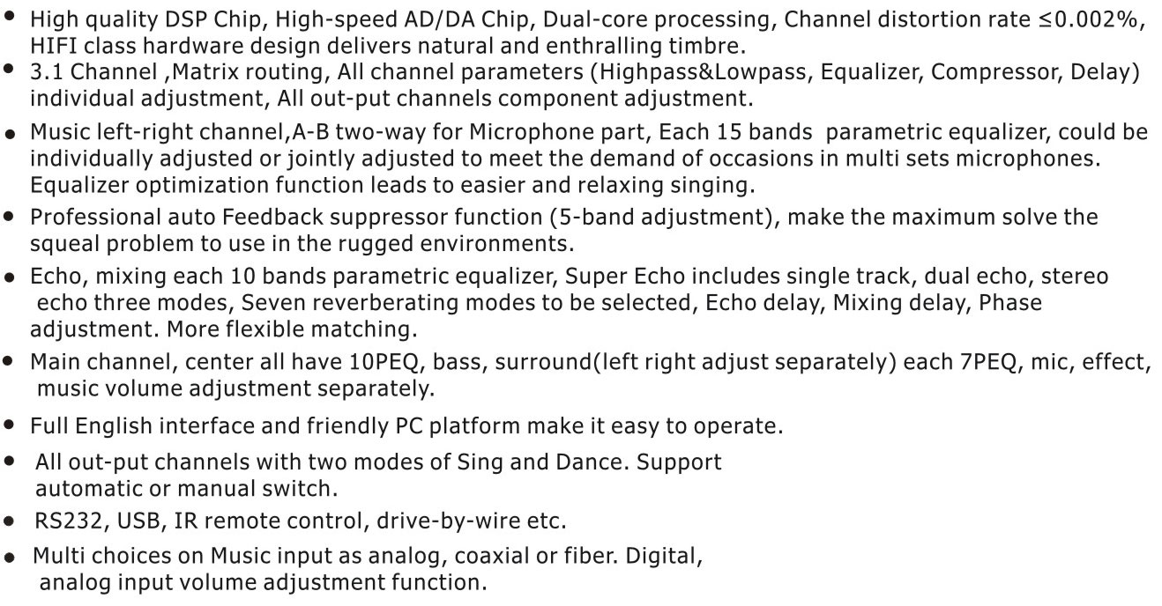
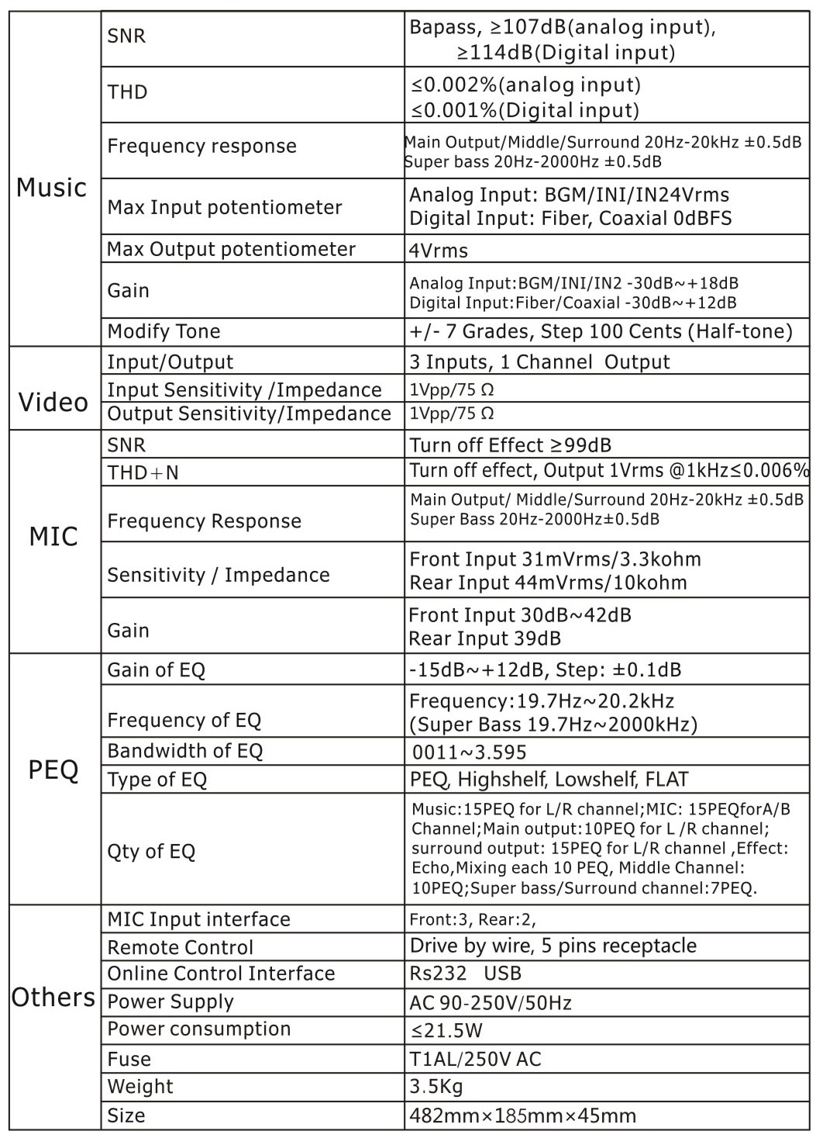

K6e 6 channel professional karaoke processor
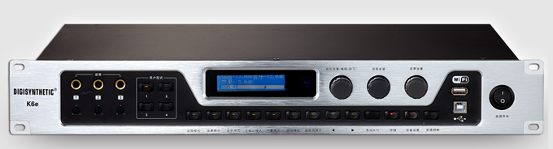
 5 bands PEQ per channel, accurate adjustment of the speaker curves.
 50ms delay for each channel output makes the flexible position of speaker.
The best for larger hall.
 Superb ECHO includes single channel, stereo, and double echo mode.
( The relevant echo of the present K6 is canceled.)
 Multi choices on Music input as analog, coaxial or fiber. Flexible response to live application.
 The adopted high speed DSP AC3brings to high quality sound effect processing.
 The breakthrough auto equalizer of input volume. Good adaptability of different sound sources.
 Innovative voice-beautified function leads to easier singing.
 15 band high-precision PEQ of mic and music processing.
Convertible PEQ into GEQ makes the modulation much easier.
 Real 5.1 channel design. It supports 5.1 channel signal input of theater mode.
 USB, RS232, IR wireless remote control, drive-by-wire, TCP/IP selected internet communication.
 Hifi class hardware design and extremely low background noise bring to the refined timber.
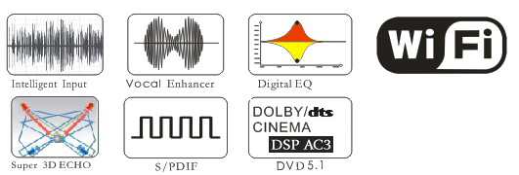
Music part | SNR | ≥102dB
 | THD | 0.01% 20Hz-20kHz
 | Frequency Response | 20Hz-20kHz ±0.5dB
 | Input sensitivity/Impedance | 0.707V/47kΩ
 | Maximum output | 9.8Vpp/60ohm balance input
 | Qty of equalizer | 15PEQ
 | Type of equalizer | PEQ GEO convertible
 | Gain of equalizer | +12dB, step±0.1dB
 | Frequency of EQ | 20Hz~20KHz
 | Bandwidth of EQ | 0.011~3.595Oct
 | Shift of EQ | ±7grade, step 100cent
 | 3 Channel stereo input  potentiometer adjustment | BGM:-∞~+6dB  DVD/AUX:-∞~+6dB
Video | Input/output | 3 channel video input,  1 channel video output
 | Input sensitivity/Impedance | 1Vpp/750 Ω
 | Output sensitivity Impedance | 1Vpp/750 Ω
Subwoofer | THD | 0.01% 20Hz-2000Hz
 | Frequency response | 20Hz-2000Hz ±0.5dB
 | Qty of EQ | 5 band PEQ
 | Type of EQ | PEQ GEO convertible
 | Gain of EQ | +12dB step±0.1dB
 | Frequency of EQ | 20Hz~2000Hz
 | Bandwidth of EQ | 0.011~3.595oct
Microphone part | SNR | ≥91dB(effect OFF)
 | THD | 0.01% 50Hz-16kHz(effect OFF)
 | Frequency Response | 50Hz-16kHz ±0.5dB
 | Input sensitivity/Impedance | 42mv/4.7kΩ
 | Maximum output | 13.8Vpp
 | Qty of equalizer | 15 PEQ
 | Type of equalizer | PEQ GEO convertible
 | Gain of equalizer | +12dB step±0.1dB
 | Frequency of EQ | 20Hz~20KHz
 | Bandwidth of EQ | 0.011~3.595oct
 | Five mic input
Others | PC control interface | RS232 interface USB interface
 | Power supply | AC 90-250V/50Hz
 | Power consumption | 10W
 | Fuse | T1AL/250V AC
 | Weight | 3.5kg
 | Size | 482mm×200mm×68mm

K6
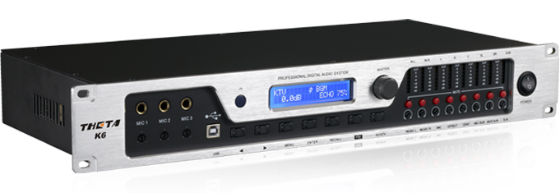
● The adopted high speed DSP brings to high quality sound effect processing.
● Patent design of super ECHO reproduces the perfect sound.
● The breakthrough auto equalizer of input volume provides better protection.
● Innovative voice-beautified function leads to easier singing.
● Newly-designed multi echo processing produces the vivid live performance effect.
● 15 band high-precision PEQ of mic and music processing. Convertible PEQ into GEQ makes the modulation much easier.
● Powerful feedback eliminator function, professional feedback eliminating capability.
● Multi surround effect mode leads to colorful singing effect.
● Real 5.1 channel design. It supports 5.1 channel signal input of theater mode.
● Hifi class hardware design and extremely low background noise bring to the refined timber.
● USB, RS232,IR wireless remote control, drive-by-wire, communication.
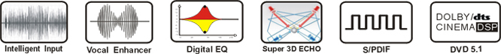
Music  part | SNR | ≥95dB
 | THD | 0.001% 20Hz-20kHz
 | Frequency response | 20Hz-20kHz ±0.5dB
 | Input sensitivity/impedance | 0.775V/47k ohm
 | Maximum output | 8Vpp/60ohm balanced output
 | Bass | 100Hz~600Hz(±12dB, step±0.5dB)
 | Alto | 600Hz~2000Hz(±12dB, step±0.5dB)
 | Treble | 2k~15k(±12dB, step±0.5dB)
 | Pitch shift | ±7grade, step100cent
 | Audio input
 | 3 channel stereo input volume potentiometer adjustment | -∞-+3dB
 | PEQ | 5 band freguency30HZ~18KHZ
 | Gain | ±12dB,Q:0.4~15
 | Delay | 21ms,step 21us
Video | Input/output | 3channel video input, 1 channel video output
 | Input sensitivity/impedance | 1Vpp/75 ohm
 | Output sensitivity/impedance | 1Vpp/75 ohm
Subwoofer | THD | 0.005% 20Hz-250Hz
 | Frequency Response | 20Hz-250Hz ±0.5dB
Microphone part | SNR | ≥80dB
 | THD | 0.01% 50Hz-16kHz(effect off)
 | Frequency response | 20Hz-20kHz ±0.5dB
 | Input sensitivity/impedance | 100mv-500mv/4.7k ohm
 | Maximum output | 12Vpp
 | Low | 100Hz- 400Hz(±9dB, step±0.5dB)
 | Middle to low | 400Hz-2kHz(±9dB, step±0.5dB)
 | Middle to high | 2kHz-4kHz(±9dB, step±0.5dB)
 | High | 4kHz-15kHZ(±9dB, step±0.5dB)
 | Centre impedance | 0.775V/47k ohm
 | Surround left right | 0.775/10k ohm
 | Five mic input | Input gain adjustable
 | PEQ | 15band freguency1000HZ~16KHZ
 | Gain | ±12dB,Q:0.4~15
AV/OK | Karaoke and home theatre switchable | KTV/AV switchable
Others | PC cortrol interface | Rs232 interface USBinterface
 | Record output | PWL adjustable
 | Power supply | AC 90-250V/50Hz
 | Power consumption | 10W
 | Fuse | T1AL/250V AC
 | Weight | 7.2kg
 | Size | 482mm×213mm×88mm

DSK3.1H
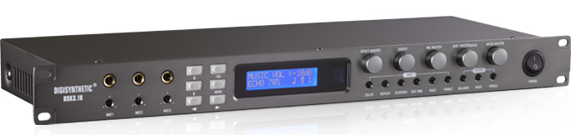
● High performance multi-DSP processing, high accuracy A/D, D/A convertor
● Left, center, right and woofer 4 output channel. Specially add the microphone center channel, 3-band full parameter digital PEQ, reverb/echo effect output function(volume adjustable, optional effects) More outstanding effect leads to more correct phase shift allocation of the singer.
● 14 class stereo digital controlling music loss-less transposition is suitable for all different voice range singers.
● Music 7 band full parameter PEQ with L-Shelf, H-shelf functions. Microphone lowcut and highcut function. Independent adjustment for treble and bass on panel. Professional limiter and microphone exciter function lead to better protection and easy singing.
● Professional stage class effect processing function, reverb, echo, reverb +echo (scaling adjustable). Thousands of effect combination modes can meet different singers' demands
● Music and microphone digital noise gate can resolve system noise on maximum.
Powerful software function, humanized interface operation, full open parameter, easy operation and 30 user memories. Convenient effect presetting bring to easy and quick sound adjustment on stage.
● Subwoofer channel, perfect crossover, 3 band full parameter PEQ, professional limiter and delay processing. more helpful to adjust sound.
● 0-21ms music delay. That matches subwoofer phase position.
● 3 channel audio& visual auto switch, BGM function.
● IR wireless remote control, computer control RS232 port, computer song request port. IR wireless receive port to meet different outside demand.
● Professional auto feedback eliminator function(multilevel adjustable sensitivity) can remove voice squealing effectively and meet the demand in severe environment.
● Full digital potentiometer leads to easy parameter data setting. 2х26LCD with backlight.
● Internet remote control function (select).
Music  part | SNR | ≥95dB
 | THD | 0.001% 20Hz-20kHz
 | Frequency response | 20Hz-20kHz ±0.5dB
 | Input sensitivity/impedance | 0.775V/47kΩ
 | Maximum output | 8Vpp/60Ω balanced output
 | Treble(increase/attenuation) | 0Hz-1KHz(±12dB, step±1dB)
 | Bass (increase/attenuation) | 1KHz-20KHz(±12dB, step±1dB)
 | Equalizer quantity | 7
 | Equalizer type | PEQ, Highshelf, Lowshelf, FLAT
 | Equalizer gain
 | Equalizer frequency | 20Hz~20KHz
 | Equalizer bandwidth | 0.011~3.595Oct
 | Equalizer Pitch | ±7grade, step100cent
 | 3 channel stereo input volume potentiometer adjustment | -∞-+3dB
Video | Input/output | 3channel video input, 1 channel video output
 | Input sensitivity/impedance | 1Vpp/75Ω
 | Output sensitivity/impedance | 1Vpp/75Ω
Subwoofer | THD | 0.007% 20Hz-250Hz
 | Frequency Response | 20Hz-250Hz ±0.5Db
 | Equalizer quantity | 3
 | Equalizer type | PEQ, Highshelf, Lowshelf, FLAT
 | Equalizer gain | ±12dB,step±0.1dB
 | Equalizer frequency | 20Hz~20KHz
 | Equalizer bandwidth | 0.011~3.595Oct
Microphone part | SNR | ≥80dB(effect on)
 | THD | 0.04% 50Hz-16kHz(effect off)
 | Frequency response | 50Hz-16kHz ±0.5dB
 | Input sensitivity/impedance | 100mv-500mv/4.7k ohm
 | EQ low | 20Hz-1KHz(±12dB, step±0.1dB)
 | EQ High | 1KHz-20KHz(±12dB, step±0.1dB)
 | Equalizer quantity | 7
 | Equalizer type | PEQ, Highshelf, Lowshelf, FLAT
 | Equalizer gain | ±12dB, step±0.1dB
 | Equalizer frequency | 20Hz~20KHz
 | Equalizer bandwidth | 0.011~3.595Oct
 | 3 channel microphone input
Others | BRO | OFF-200Hz adjustable
 | Remote control | One way line control, 5 pins receptacle
 | RS232 interface | 9 pins receptacle
 | Power supply | AC 90-250V/50Hz
 | Power consumption | 10W
 | Fuse | T1AL/250V AC
 | Weight | 3.5kg
 | Size | 482mm×150mm×45mm

K3S
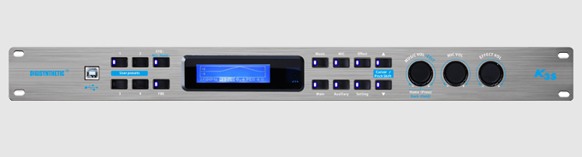
・The design for low-noise mike amplifier makes the sound more clear and sweeter;
・The 5th generation Reverb algorithm with professional early reflections and modulation give more excellent sound field.
・The independent gain controllers on effect input/output bring more flexible and accurate process;
・Professional Pitch shift algorithm for music of ±12 Grades(Pure 8 sound interval)
・The Aux outputs with full frequency range can be configured flexibly as: sub-woofer + center,stereo surround,subwoofer + surround, center + surround;
・USB interface with driver free to make convenient connection with PC;
Music
SNR |  | Bypass, Pitch-Shifter Off | ≥96dB(Analog), ≥100dB(S/PDIF)
THD+N |  | Output +4dBu, 1kHz | ≤0.003%(Analog), ≤0.002%(S/PDIF)
Frequency Response |  | L/R/C/SL/SR | 20Hz-20kHz ±0.5dB
 |  | S.W | 20Hz-2000Hz ±0.5dB
Max Input Level |  | Analog Input: IN1 / IN2 | 4Vrms
 |  | S/PDIF Input: Optical | 0dBFS = 2Vrms
Max Output Level |  |  | 4Vrms
Gain |  | Analog Input: IN1 / IN2 | -30dB~+12dB
 |  | S/PDIF Input: Optical | -42dB~+12dB (Trim: -12dB~0dB)
Pitch-Shifter |  |  | ±12 Pitches, 100 Cent (Half-Tone) / Step
Mike
SNR |  | Bypass, Effect Off | ≥86dB
THD+N |  | Output +4dBu, 1kHz | ≤0.01%
Frequency Response |  | L/R/C/SL/SR | 20Hz-20kHz ±0.5dB
 |  | S.W | 20Hz-2000Hz ±0.5dB
Sensitivity / Impedance |  | 3-CH Rear Inputs(Tow Group)  @ DSP Gain 0dB | 2.4mVrms/3.3kΩ
Gain |  | Potentiometer Adjust Range | +15dB~+60dB
 |  | DSP Adjust Range | -30dB ~+18dB
Parameter Equalizer& Filter
PEQ/Lo-Shelf/Hi-Shelf | Bands: Music 5,Mike 14×2,Main Output 6,Auxiliary Output 3,Echo 3,Reverb 2
 | Frequency: 19.7Hz~20.2kHz,  19.7Hz~2000Hz (S.W) |  | Gain: -15dB~+12dB  Bandwidth(Oct): 0.011~3.595
Sub-Woofer Filter | HPF:19.7Hz~1kHz |  | LPF:35.1Hz~2kHz
 | Roll-off:12dB/24dB/36dB/48dB |  | Type: Flat/Bessel/Butterworth/Linkwitz-Riley
Others
Remote Control |  | One Infrared Receiver
Online Control |  | USB (Type B, Driver Free)
Mains Input |  | 110V-240Vac 50/60Hz
Power Consumption |  | ≤12W
Fuse Size |  | T1AL/250VAC
Net Weight |  | 2.0kg
Dimension (W×H×D) |  | 482×158×45(mm)

TK250A DSP KTV amplifier
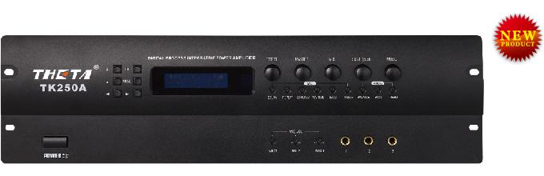
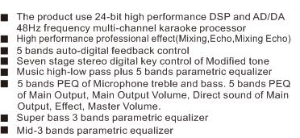
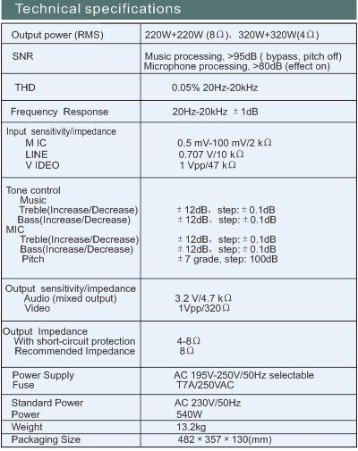
KTV-5.0
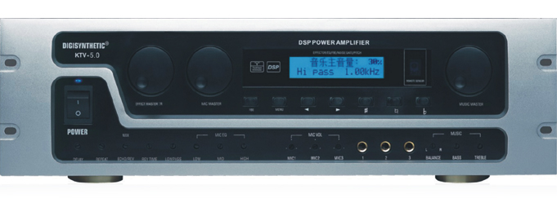
● High performance multi-DSP processing, high accuracy A/D,D/A convertor, digital potentiometers parameters adjustable
● Truly 5 channel KTV amplifier, left, right, center and surround 5 channel output. Specially add microphone center channel, reverb/echo effect output function (volume adjustable, effect model selectable), effect is more outstanding
● The function is similar to digital mixer, flexible matrix output, human voice and music for each channel adjustable4-band microphone PEQ, 3-band music PEQ, panel treble & bass adjustment independently, professional limit processing, voice enhance model, which let the singer take it easy
● 14 class stereo digital key control music undamaged modified tone, which suitable for different voice range. 14 class microphone pitch
● 3 channel audio & video auto switch, BGM function
● Professional stage class effect processing function, reverb, echo, reverb+echo (ratio adjustable), thousand effect mix together, which can meet different singer's demand
● Music, microphone digital noise gate, can solve the system noise max
● Music delay 0-21ms, match with subwoofer phase position
● Strong software function, humanity interface operation, full open parameter, easy operation and 10 user memories, simple preset effect and more helpful to adjust sound quality
● Subwoofer channel signal output, crossover frequency adjustable
● Professional auto feedback function, can deduct voice squeal efficiently, which can meet the harsh environmental demands
Output Power(rms) | 4Ω | RMS | 500x2
 | 8Ω | RMS | 2×300W
 |  | C | 100
 |  | SR, SL | 100W
SNR |  |  | OUTPUT POWER(RMS)
THD |  |  | 0.3% 20Hz-20KHz, 2channels 2×100W(RMS)
Frequency Response |  |  | 20Hz-20KHz ±1dB
Input Sensitivity/Impedance
Microphone |  |  | 0.5mv-100mv/2KΩ
Line |  |  | 0.707Vrms/10KΩ
Video |  |  | 1Vpp/47 kΩ
Music Tone Control
Treble(increase/decrease) |  |  | ±12dB, step±1dB
Bass(increase/decrease) |  |  | ±12dB, step±1dB
Micphone equalizer
Treble(increase/decrease) |  |  | ±6dB, step±1dB
Bass(increase/decrease) |  |  | ±6dB, step±1dB
Pitch |  |  | ±7grade, step±100db
Output Sensitivity/Impedance
Audio frequency |  |  | 3.2v/4.7KΩ
Videp frequency |  |  | 1vpp/320KΩ
Output Impedance
Short circuit function |  |  | 4-8KΩ
Recommended impedance |  |  | 8Ω
Power supply |  |  | AC 200V-250V/50Hz selectable
Power consumption |  |  | 700W
Fuse |  |  | F15A/250VAC
AC Power Output Socket |  |  | Switched 200W Unswitched 300W
Size（mm） |  |  | 3U 482mm×357mm×132mm
Weight（Kg） |  |  | 17kg

Обработка звука
DS418E/DS216E/DS214E Digital loudspeaker management
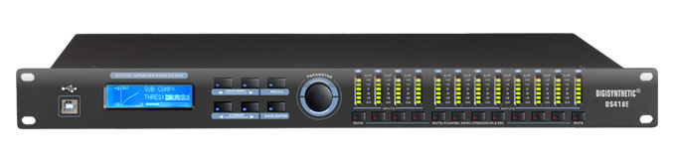
 Dynamic range: 112dB
 Input/Output 7 band PEQ
 Over-long delay,1s for input and 1s for output
 Intelligent compressor and limiter
 Friendly UI software,USB interface connection
 RS485 remote control,one PC can control multi processors.

DS428E/DS226E/DS224E Digital loudspeaker management
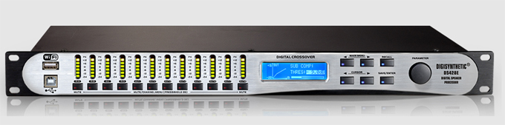
 Input 9 band PEQ (Including Phase EQ), 31 band GEQ
 Output 9 band PEQ
 Dynamic range: 108 dB
 Over-long delay, 2S for each input and 2S for each output
 Intuitive and friendly UI software
 wide diapason, natural and delicate timber
 30 kinds of system preset
 External WIFI modular interconnection
 | DS428E | DS226E | DS224E
Input/output | 4in8out | 2in6out | 2in4out
Input gain | -40~12dB,0.1dB step | -40~12dB,0.1dB step | -40~12dB,0.1dB step
Output gain | -40~12dB,0.1dB step | -40~12dB,0.1dB step | -40~12dB,0.1dB step
Input delay | 2s, step 21us | 2s, step 21us | 2s, step 21us
Output delay | 2s, step 21us | 2s, step 21us | 2s, step 21us
Input PEQ | 9/CH | 9/CH | 9/CH
Output PEQ | 9/CH | 9/CH | 9/CH
EQ gain | -30~15dB, step 0.1dB | -30~15dB, step 0.1dB | -30~15dB, step 0.1dB
EQType | PEQ | PEQ | PEQ
 | Low shelf | Low shelf | Low shelf
 | High shelf | High shelf | High shelf
 | PHASE EQ | PHASE EQ | PHASE EQ
EQ frequency | 19.7~21.9KHz | 19.7~21.9KHz | 19.7~21.9KHz
EQ Bandwidth | PEQ 0.016~4 OCT | PEQ 0.016~4 OCT | PEQ 0.016~4 OCT
Input GEQ | 31 | 31 | 31
phase EQ | Phase EQ central frequency 20-20KHZ,  phase change 180-0 , min step 2 ,max step 10
Crossover  frequency | 19.7~21.9KHz | 19.7~21.9KHz | 19.7~21.9KHz
Crossover slope | 12,24,36,48 | 12,24,36,48 | 12,24,36,48
Compressor  threshold | 20~-20dBu,step 0.5dB | 20~-20dBu,step 0.5dB | 20~-20dBu,step 0.5dB
Compressor ratio | 1/1~1/40 | 1/1~1/40 | 1/1~1/40
Attack time | 1~100ms，step 1ms | 1~100ms，step 1ms | 1~100ms，step 1ms
Release time | [1,2,4, 8,16,32]* | [1,2,4, 8,16,32]* | [1,2,4, 8,16,32]*
 | [1~100ms， step 1ms] | [1~100ms， step 1ms] | [1~100ms， step 1ms]
Dynamic range | 108 | 108 | 108
CMMR | 60 | 60 | 60
Crosstalk | -100 | -100 | -100
Distortion | 0.002%（1KHz，1Vrms） | 0.002%（1KHz，1Vrms） | 0.002%（1KHz，1Vrms）
System preset | 30 | 30 | 30
Power | 90-240V/AC 50Hz-60Hz
Weight | 3.6kg
Size | 482mm×218mm×45mm

DMX8
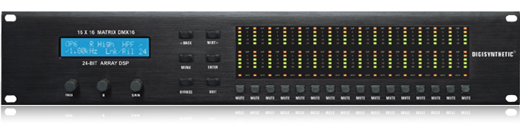
● 28-bit DSP Processing in Parallel Dynamic range: 102dB, 48KHz sampling rate
● Matrix Routing, Balance input/output control
● 5 bands PEQ per channel, all Parameters Adjustable
● Crossover slope: 6, 12, 18, 24 and 48dBper octave Filters Type: Butterworth , Bessel, Linkwitz-Riley
● Up to 1364ms/per Channel, 0.1ms Step
● Independent Compressor and Limiter per Channel, All Parameters Adjustable
● Revers Polarity Control on Each Channel, Digital Noise-gate
● Network connection port: RS232, RS485 and USB port 16 user memories
● 16×5 bands digital level meter
● 2×20 character LCD with backlight
Input impedance | 10K ohm electronic balance input
Input CMRR | >50dB (30Hz ~ 20KHz)
Output impedance | ＜50Ω
Max. Output level | Vpp=4V balance, Vpp=7.6V
Frequency response | 20Hz~20.0kHz
Dynamic range | 102dB
Distortion | 0.005%(THD)
Max. Delay | 1365ms
Output gain | 40dB~+6dB ±0.5dB
Input gain | 40dB~+6dB ±0.5dB
PEQ
Filter
Gain | ±12dB in 0.1dB steps
Centre frequency | 20Hz~20kHz
Q value | 0.4~128
Shelving
Lo-shelf： | 20Hz~1kHz
Hi-shelf： | 1kHz~20kHz
Shelf gain： | ±12dB in 0.1dB steps
HPF&LPF
Filter
Frequency ( HP ) | ＜10Hz~16.0kHz
Frequency ( LP ) | 35Hz~20.0kHz
COMPRESSOR
Threshold | 24~+12dB
Attack | 0.1~100ms
Release | 10ms~5s
Ratio | 1:128~128:128
Boost | ×1, ×2, ×4, ×8
LIMITER
Threshold | -Inf,-53dB~+10Db
Attack time | 20us~3ms
Hold time | 0~10ms
Release time | 10ms~5s
Response curve | Butterworth 6dB、12dB、18dB、24dB、48dB  Bessel 12dB、18dB、24dB、48dB  Linkwitz-Riley 24dB、48dB
Voltage | 90-240V/AC 50Hz-60Hz
Weight | 7.2kg
Size | 482mm×213mm×88mm

DMX16
● 28-bit DSP Processing in Parallel Dynamic range: 102dB, 48KHz sampling rate
● Matrix Routing, Balance input/output control
● 5 bands PEQ per channel, all Parameters Adjustable
● Crossover slope: 6, 12, 18, 24 and 48dBper octave Filters Type: Butterworth , Bessel, Linkwitz-Riley
● Up to 1364ms/per Channel, 0.1ms Step
● Independent Compressor and Limiter per Channel, All Parameters Adjustable
● Revers Polarity Control on Each Channel, Digital Noise-gate
● Network connection port: RS232, RS485 and USB port 16 user memories
● 32 x 5 bands digital level meter
● 2×20 character LCD with backlight
Input impedance | 10K ohm electronic balance input
Input CMRR | >50dB (30Hz ~ 20KHz)
Output impedance | ＜50Ω
Max. Output level | Vpp=4V balance, Vpp=7.6V
Frequency response | 20Hz~20.0kHz
Dynamic range | 102dB
Distortion | 0.005%(THD)
Max. Delay | 1365ms
Output gain | 40dB~+6dB ±0.5dB
Input gain | 40dB~+6dB ±0.5dB
PEQ
Filter
Gain | ±12dB in 0.1dB steps
Centre frequency | 20Hz~20kHz
Q value | 0.4~128
Shelving
Lo-shelf： | 20Hz~1kHz
Hi-shelf： | 1kHz~20kHz
Shelf gain： | ±12dB in 0.1dB steps
HPF&LPF
Filter
Frequency ( HP ) | ＜10Hz~16.0kHz
Frequency ( LP ) | 35Hz~20.0kHz
COMPRESSOR
Threshold | 24~+12dB
Attack | 0.1~100ms
Release | 10ms~5s
Ratio | 1:128~128:128
Boost | ×1, ×2, ×4, ×8
LIMITER
Threshold | -Inf,-53dB~+10Db
Attack time | 20us~3ms
Hold time | 0~10ms
Release time | 10ms~5s
Response curve | Butterworth 6dB、12dB、18dB、24dB、48dB  Bessel 12dB、18dB、24dB、48dB  Linkwitz-Riley 24dB、48dB
Voltage | 90-240V/AC 50Hz-60Hz
Weight | 7.2kg
Size | 482mm×213mm×88mm

DS428D
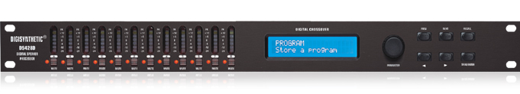
● 24-bit dual DSP, high performance AKM A/D AK5392 and CIRRUS D/A CS4382
● Matrix Routing, 4 Inputs / 8 Outputs
● Crossover slope: 12, 18, 24 and 48dB per Octave, Filters Type: Butterworth, Bessel, Linkwitz-Riley
● 6 bands PEQ at input stage, 4 bands PEQ at output stage, EQ type: parametric, L-Shelf, H-Shelf
● PEQ bandwidth range: 1/64 ~ 4 Octave
● Up to 682ms Maximum Delay time for input delay; Up to 2s Maximum delay time for output delay
● Independent Compressor, threshold, ratio, attack time and release time adjustable
● 30 user memories, intuitive and friendly PC interface, USB port
● Network input/output port for the program copy
● 2×20 character LCD with backlight
● 12×7 band input/output level meter
● Switch power supply: 90 ~ 250V
Input impedance | 10K ohm electronic balance input
Max. input level | 4Vrms
Input CMRR | 55Db
Input cannon | DY-08
Sampling rate | 48KHz
Output impedance | 150Ω
Max. output level | 2Vrms
Output cannon | DY -09
Input gain | -40.0dB ~ 12.0dB, step: 0.1dB
Output gain | -40.0dB ~ 12.0dB, step: 0.1dB
Input delay | 682.52ms, step: 21us
Output delay | 2s, step: 21us
EQ | 6 bands EQ at input stage 4 bands EQ at output stage
EQ type | Parametric, L-Shelf 6dB, L-Shelf 12dB,  H-Shelf 6dB, H-Shelf 12dB
EQgain | -30dB ~ 15dB, step: 0.1dB
EQ frequency | 19.7Hz~21.9kHz
PEQ bandwidth | 0.016~4.000Oct
Crossover filter
Frequency | 19.7Hz~21.9kHz, OFF
Crossover Slope | 12, 18, 24, 48dB
Filters Type | Butterworth, Bessel, Linkwitz-Riley
Limiter
Limiter threshold | -20dBu ~ 10dBu, step: 1dBu
Limiter ratio | 1.2/1, 1.5/1, 2/1, 3/1, 4/1, 6/1, 10/1, 20/1, Infinite
Attack time | 0.5, 1, 2, 5, 10, 20, 50ms/dB
Release time | 10, 20, 50, 100, 200, 500ms/dB, 1sec/dB
Performance
Frequency response | 0~20KHz(±0.1dB)
Dynamic range | 102dB
Channel separation | 100dB
Distortion | THD 0.003%(1KHz, 1Vrms)
Voltage | AC90V~250V
Fuse | 1A, AC250V
Power | 30W
Weight | 3.6kg
Size | 482mm×218mm×45mm

DS224D
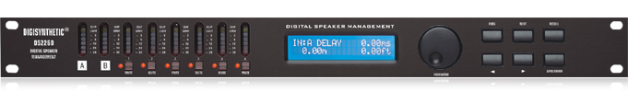
● 24-bit dual DSP, high performance AKM A/D AK5392 and CIRRUS D/A CS4382
● Matrix Routing, 2 Inputs / 4 Outputs
● Crossover slope: 12dB, 18dB, 24dB and 48dB. Filters Type: Butterworth, Bessel, Linkwitz-Riley
● 6 bands PEQ at input stage, 4 bands PEQ at output stage EQ type: parametric, L-Shelf, H-Shelf
● PEQ bandwidth range: 1/64 ~ 4 Octave
● Up to 682ms Maximum Delay time for input delay; Up to 2s Maximum delay time for output delay
● Independent Compressor, threshold, ratio, attack time and release time adjustable
● 30 user memories, intuitive and friendly PC interface, USB port
● Network input/output port for the program copy
● 2×20 character LCD with backlight
● 8 ×7 bands or 6×7 bands input/output level meter
● Switch power supply: 90 ~ 250V
Input impedance | 10K ohm electronic balance input
Max. input level | 4Vrms
Input CMRR | 55Db
Input cannon | DY-08
Sampling rate | 48KHz
Output impedance | 150Ω
Max. output level | 2Vrms
Output cannon | DY -09
Input gain | -40.0dB ~ 12.0dB, step: 0.1dB
Output gain | -40.0dB ~ 12.0dB, step: 0.1dB
Input delay | 682.52ms, step: 21us
Output delay | 2s, step: 21us
EQ | 4 bands EQ at input stage
EQ type | Parametric, L-Shelf 6dB, L-Shelf 12dB,  H-Shelf 6dB, H-Shelf 12dB
EQgain | -30dB ~ 15dB, step: 0.1dB
EQ frequency | 19.7Hz~21.9kHz
PEQ bandwidth | 0.016~4.000Oct
Crossover filter
Frequency | 19.7Hz~21.9kHz, OFF
Crossover Slope | 12, 18, 24, 48dB
Filters Type | Butterworth, Bessel, Linkwitz-Riley
Limiter
Limiter threshold | -20dBu ~ 10dBu, step: 1dBu
Limiter ratio | 1.2/1, 1.5/1, 2/1, 3/1, 4/1, 6/1, 10/1, 20/1, Infinite
Attack time | 0.5, 1, 2, 5, 10, 20, 50ms/dB
Release time | 10, 20, 50, 100, 200, 500ms/dB, 1sec/dB
Performance
Frequency response | 0~20KHz(±0.1dB)
Dynamic range | 102dB
Channel separation | 100dB
Distortion | THD 0.003%(1KHz, 1Vrms)
Voltage | AC90V~250V,50~60Hz
Fuse | 1A, AC250V
Power | 30W
Weight | 3.6kg
Size | 482mm×218mm×45mm

DS2012 Digital Auto Feedback Eliminator
●24-bit high speed and high performance DSP to realize speedy feedback frequency scan and autonotch feedback, which guaranteesthe signal resolution and dynamic range; ・64/128 Sampling high resolution; 24-bit A/D,D/A high-speed conversion signal;
●Dual-channel input, Each channel has12 auto-search feedback points. Targeted eliminated；
●24 Filters with LED Screen;
●Every filter with separate dynamic and static filter, auto processing and lock the TrapWavefrequency;
●User could set the eliminating strength for each channel;
●The Potentiometer LED indicates the input signal power;
●Factory default settings, Plug & Play, simple to operate interface.
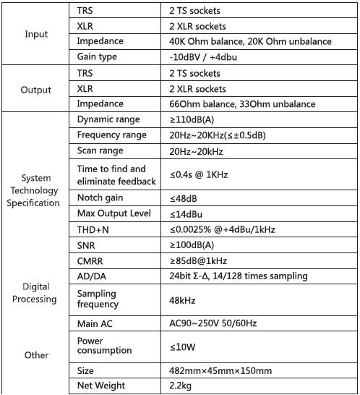

DS2024 Digital Auto Feedback Eliminator
